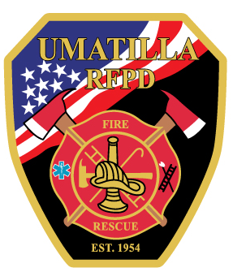
To Save Lives and Property

UMATILLA FIRE DISTRICT BUDGET AGENDA
June 5, 2024 6:30 PM

MEETING CALLED TO ORDER:

ROLL CALL:

ELECTION OF BUDGET COMMITTEE CHAIRMAN:

CLERK SUMMARY:

PROPOSAL TO ADOPT BUDGET:

ADJOURNMENT

THIS INSTITUTION IS AN EQUAL OPPORTUNITY PROVIDER. DISCRIMINATION IS PROHIBITED BY FEDERAL LAW. SPECIAL ACCOMODATIONS TO ATTEND OR PARTICIPATE IN A PUBLIC MEETING OR OTHER FUNCTION CAN BE PROVIDED BY CONTACTING URFPD AT (541) 922-3718.

Kyle Sipe, Chairman Jeannie Bowman, Clerk

