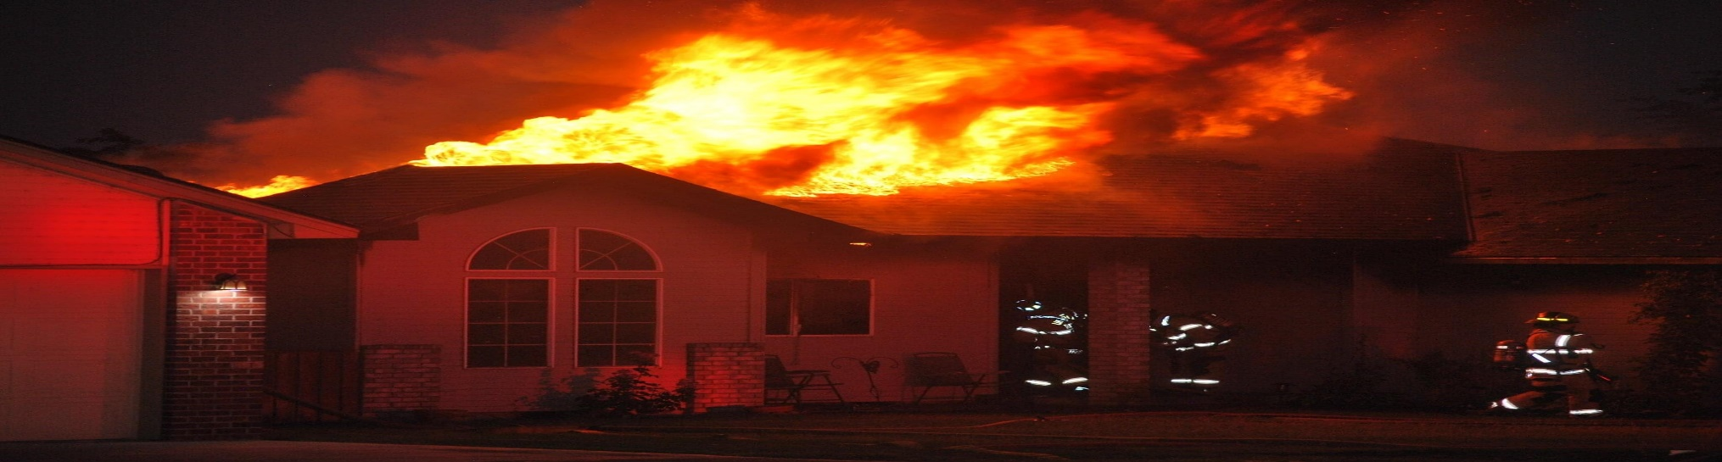

*Umatilla Rural Fire Protection Department*

Firefighter Intern Program

***Minimum Qualifications***

* Must be at least 18 years old.
* Non-smoker.
* No felony records.
* Meet the physical fitness requirements recommended in NFPA 1582.
* Hold a valid and insurable or driver’s license.
* Maintain a 2.5 GPA with a C grade minimum in each class.

***Start Date- September 2, 2024***

***Opens – June 27, 2024***

***Closes – August 5, 2024***

***Benefits***

* Living accommodations including utilities and laundry while on shift .
* Up to $1750 college tuition reimbursement and cover other fees while working on a degree in emergency services or related fields.
* Training in all aspects of structure and wildland firefighting, emergency medicine and fire prevention.
* Experience working with trained professionals.

***Job Description***

The Firefighter intern program is designed to provide student with valuable training and benefits, but more importantly, the experience that cannot be attained in a classroom. This useful knowledge is gained by working side by side with our professional personnel on day-to-day operations and emergency scenes.

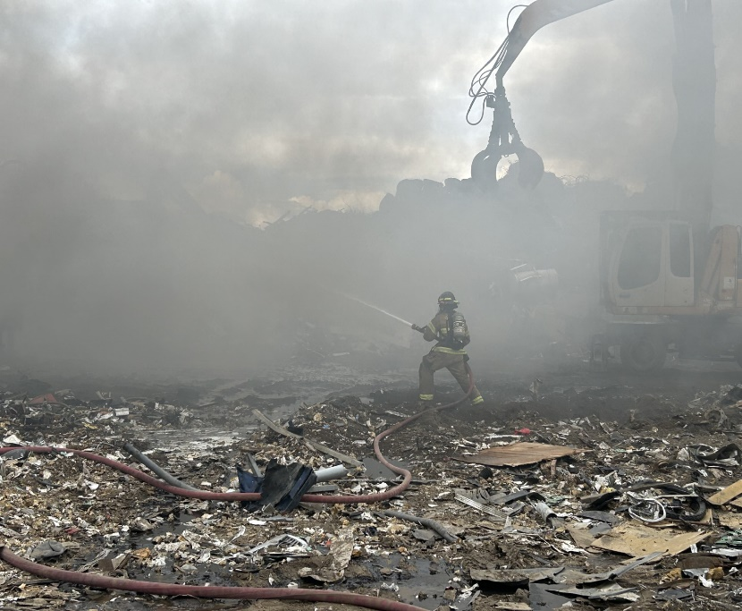

***Join the family***

***Umatilla Rural Fire Protection District works a shift schedule of 2 days on, 4 days off. In the 10 days firefighters work every month they train, lift weights, prepare and respond to emergency situations involving fires, hazardous materials, medical emergencies, and other disasters. Our organization is a capable, aggressive fire department that focuses on safely preserving the past and protecting the future of those we serve.***

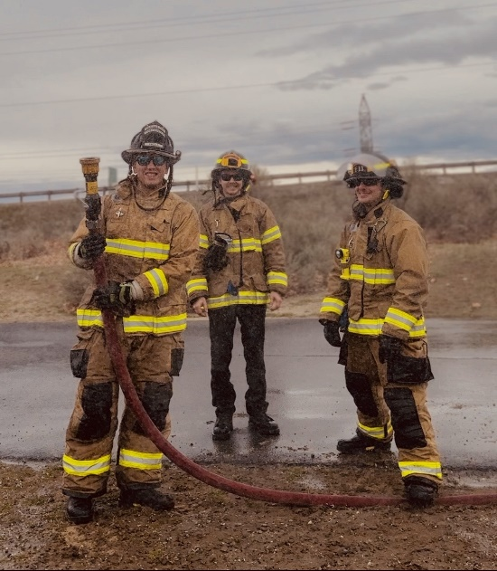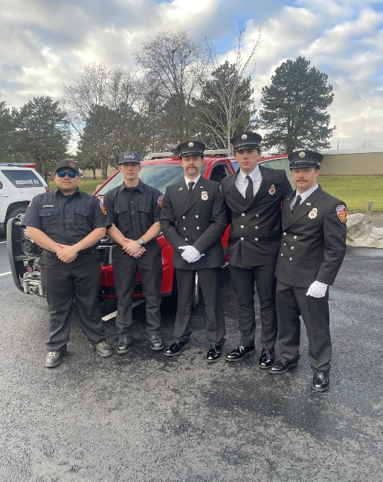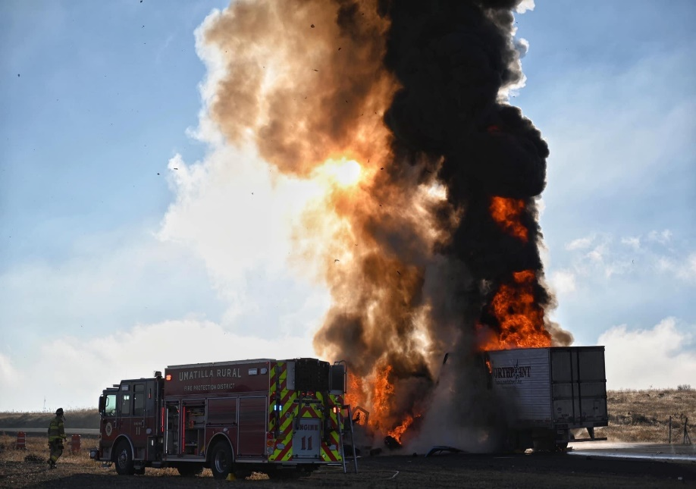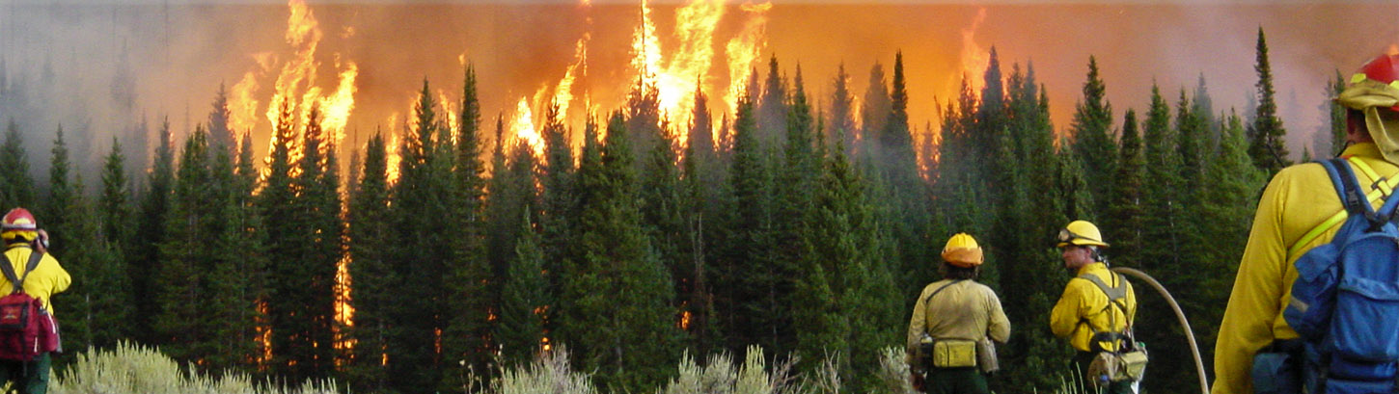

***Resident Intern Coordinator- Jordy McCrakcen-*** [***jordy@umatillafire.org***](mailto:jordy@umatillafire.org) ***or Recruitment Coordinator Dakota Paola- Dakota.paola@umatillafire.org***